**ATLIQ-HARDWARES-CONSUMER-GOODS-Ad-Hoc-INSIGHTS**

1. Provide the list of markets in which customer "Atliq Exclusive" operates its business in the APAC region.  
  
select distinct market from dim_customer

where customer = "Atliq Exclusive" and region = "APAC"  
  
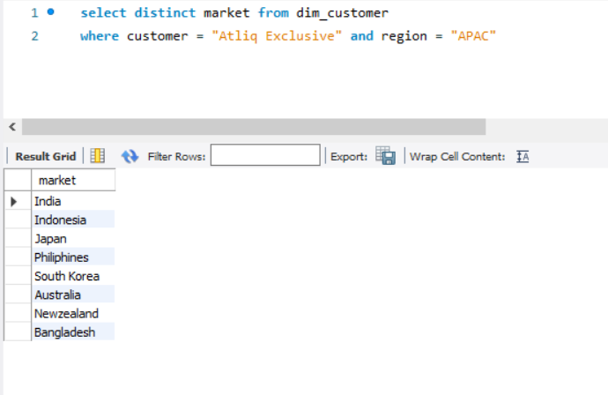

2. What is the percentage of unique product increase in 2021 vs. 2020? The final output contains these fields,  
unique_products_2020,  
unique_products_2021,  
percentage_chg  
  
select X.A AS unique_product_2020, Y.B AS unique_product_2021, ROUND((B-A)*100/A, 2) AS percentage_chg

From  
(

(select count(distinct(product_code)) AS A from fact_sales_monthly

where fiscal_year = 2020) X,

(select count(distinct(product_code)) AS B from fact_sales_monthly

where fiscal_year = 2021) Y

)  
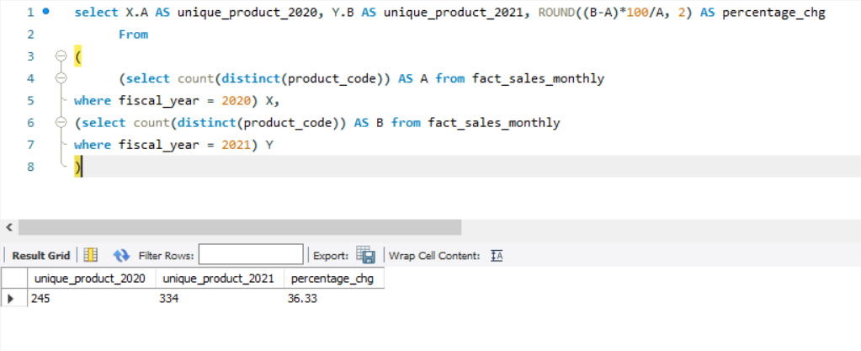

3. Provide a report with all the unique product counts for each segment and sort them in descending order of product counts. The final output contains 2 fields, segment  
product_count  
  
select segment ,count(distinct(product)) as "product_count" from dim_product

group by segment

order by product_count desc

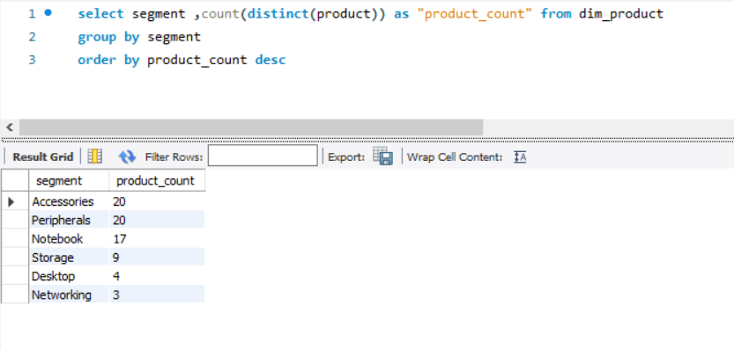

# 4. Follow-up: Which segment had the most increase in unique products in 2021 vs 2020? The final output contains these fields, segment product_count_2020 product_count_2021 difference

with CTE1 AS

(select P.segment AS A , count(distinct(FS.product_code)) AS B from dim_product P

join fact_sales_monthly FS

on FS.product_code = P.product_code

where FS.fiscal_year = "2020"

group by P.segment),

CTE2 AS

(select P.segment AS C , count(distinct(FS.product_code)) AS D from dim_product P

join fact_sales_monthly FS

on FS.product_code = P.product_code

where FS.fiscal_year = "2021"

group by P.segment)

select CTE1.A as segment, CTE1.B as product_count_2020, CTE2.D as product_count_2021, (CTE2.D - CTE1.B) AS difference

from CTE1, CTE2

where CTE1.A = CTE2.C

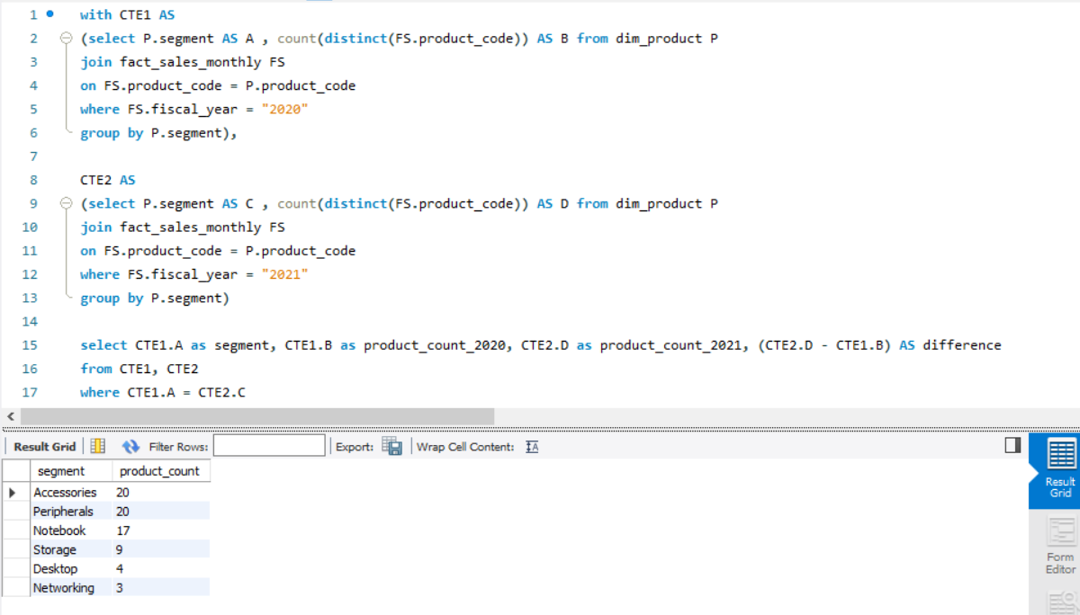

# 5. Get the products that have the highest and lowest manufacturing costs. The final output should contain these fields, product_code product manufacturing_ cost

select P.product, P.product_code, manufacturing_cost from dim_product P

join fact_manufacturing_cost FM

on FM.product_code = P.product_code

where manufacturing_cost in (

select min(manufacturing_cost) as manufacturing_cost from fact_manufacturing_cost

union

select max(manufacturing_cost) as manufacturing_cost from fact_manufacturing_cost

order by manufacturing_cost desc

)

order by manufacturing_cost desc

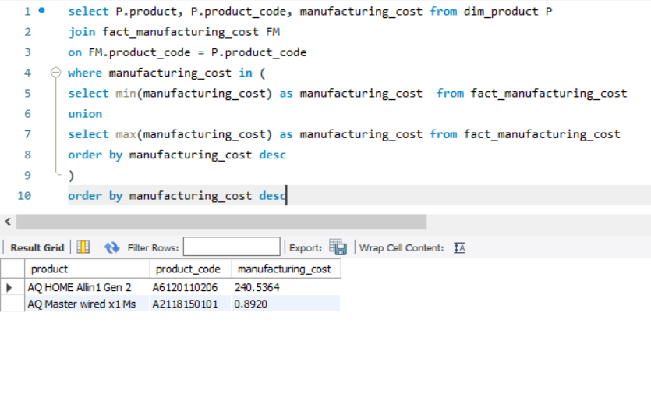

# 6. Generate a report which contains the top 5 customers who received an average high pre_invoice_discount_pct for the fiscal year 2021 and in the Indian market. The final output contains these fields, customer_code customer average_discount_percentage

select FI.customer_code, DI.customer, concat(round(avg(pre_invoice_discount_pct)*100,2), "%") as avg_discount_percentage

from fact_pre_invoice_deductions FI

JOIN dim_customer DI

on FI.customer_code = DI.customer_code

WHERE market = "India" and fiscal_year = 2021

group by customer, customer_code

order by avg(pre_invoice_discount_pct) desc

limit 5

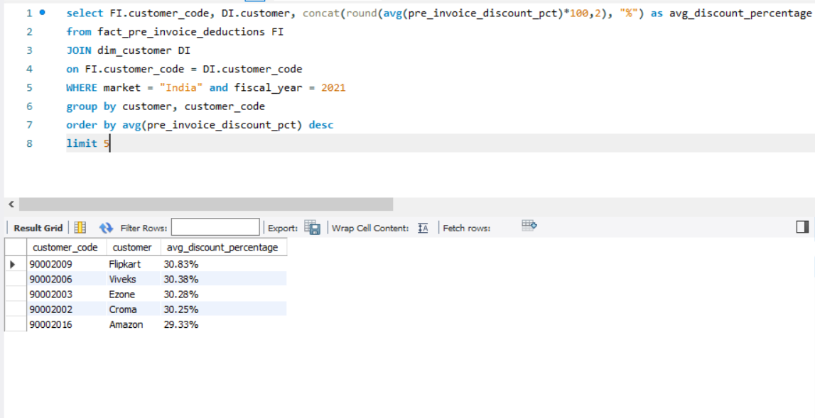

# 7. Get the complete report of the Gross sales amount for the customer “Atliq Exclusive” for each month. This analysis helps to get an idea of low and high-performing months and take strategic decisions. The final report contains these columns: Month Year Gross sales Amount

select monthname(date) as Month_name, year(date) as year_name, round(sum(FG.gross_price * FS.sold_quantity) / 10000000,2) as Gross_sales_amount_millions

from fact_sales_monthly FS

join fact_gross_price FG

on FS.product_code = FG.product_code

join dim_customer DC

on DC.customer_code = FS.customer_code

where DC.customer = "Atliq Exclusive"

group by month_name,year_name

order by year_name

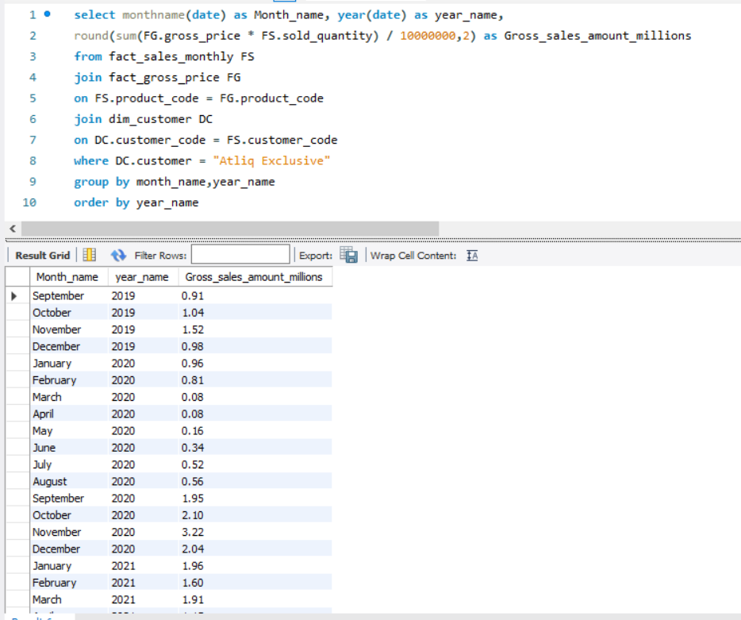

# 8. In which quarter of 2020, got the maximum total_sold_quantity? The final output contains these fields sorted by the total_sold_quantity, Quarter total_sold_quantity

select

case

when month(date) in (9,10,11) then "Q1"

when month(date) in (12,1,2) then "Q2"

when month(date) in (3,4,5) then "Q3"

when month(date) in (6,7,8) then "Q4"

end as quarter,

sum(sold_quantity) as total_quantity_sold from fact_sales_monthly

where fiscal_year = 2020

group by quarter

order by total_quantity_sold desc

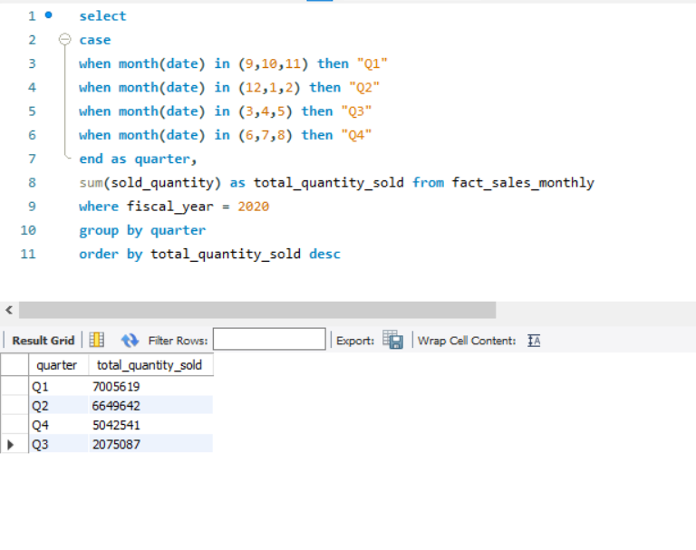

# 9. Which channel helped to bring more gross sales in the fiscal year 2021 and the percentage of contribution? The final output contains these fields, channel gross_sales_mln percentage

with gross_sales as (

select DC.channel, round(sum(FG.gross_price * FS.sold_quantity)/1000000,2) as gross_sales_mln

from fact_sales_monthly FS

join fact_gross_price FG

on FS.product_code = FG.product_code

and FS.fiscal_year = FG.fiscal_year

join dim_customer DC

ON DC.customer_code = FS.customer_code

where FG.fiscal_year = 2021

group by DC.channel

)

select channel, gross_sales_mln, concat(round((gross_sales_mln / sum(gross_sales_mln) over()) *100,2), "%") as percentage

from gross_sales

order by percentage desc

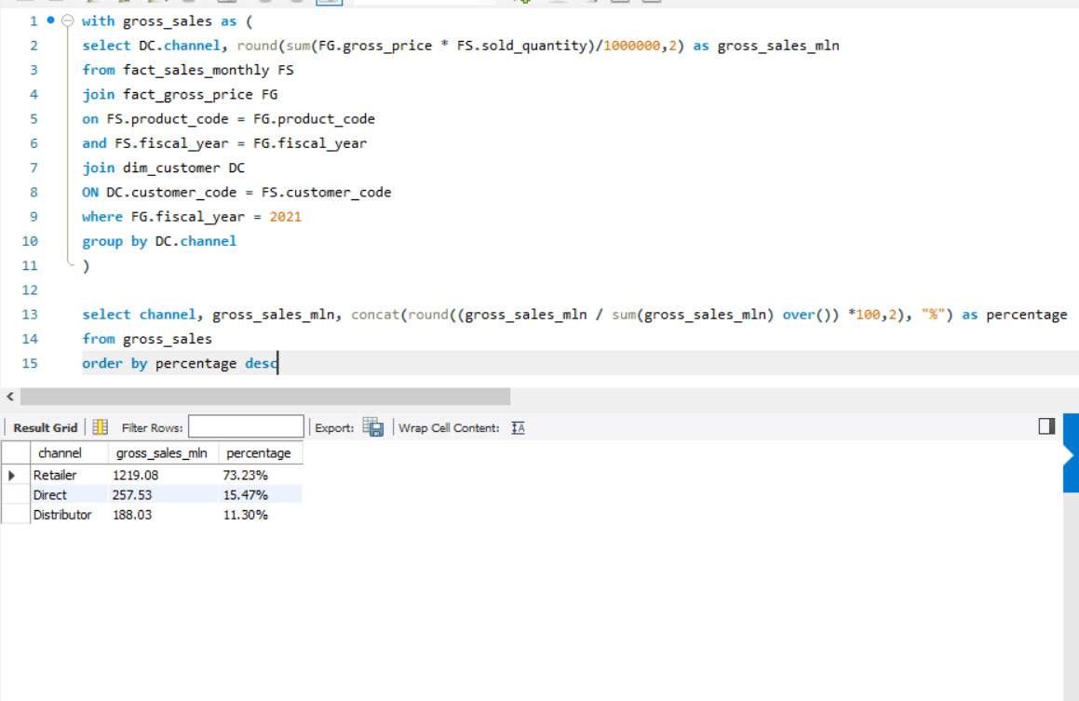

# 10. Get the Top 3 products in each division that have a high total_sold_quantity in the fiscal_year 2021? The final output contains these fields, division product_code product total_sold_quantity rank_order

with top_sold_product as (

select DP.division, DP.product_code, DP.product, sum(sold_quantity) as total_sold_quantity

from dim_product DP

join fact_sales_monthly FS

on DP.product_code = FS.product_code

where fiscal_year = 2021

group by DP.division, DP.product_code, DP.product

order by total_sold_quantity desc

),

top_sold_per_division_rank_order as (

select division,

product_code,

product,

total_sold_quantity,

rank() over(partition by division order by total_sold_quantity desc) as rank_order

from top_sold_product

)

select * from top_sold_per_division_rank_order

where rank_order <=3

